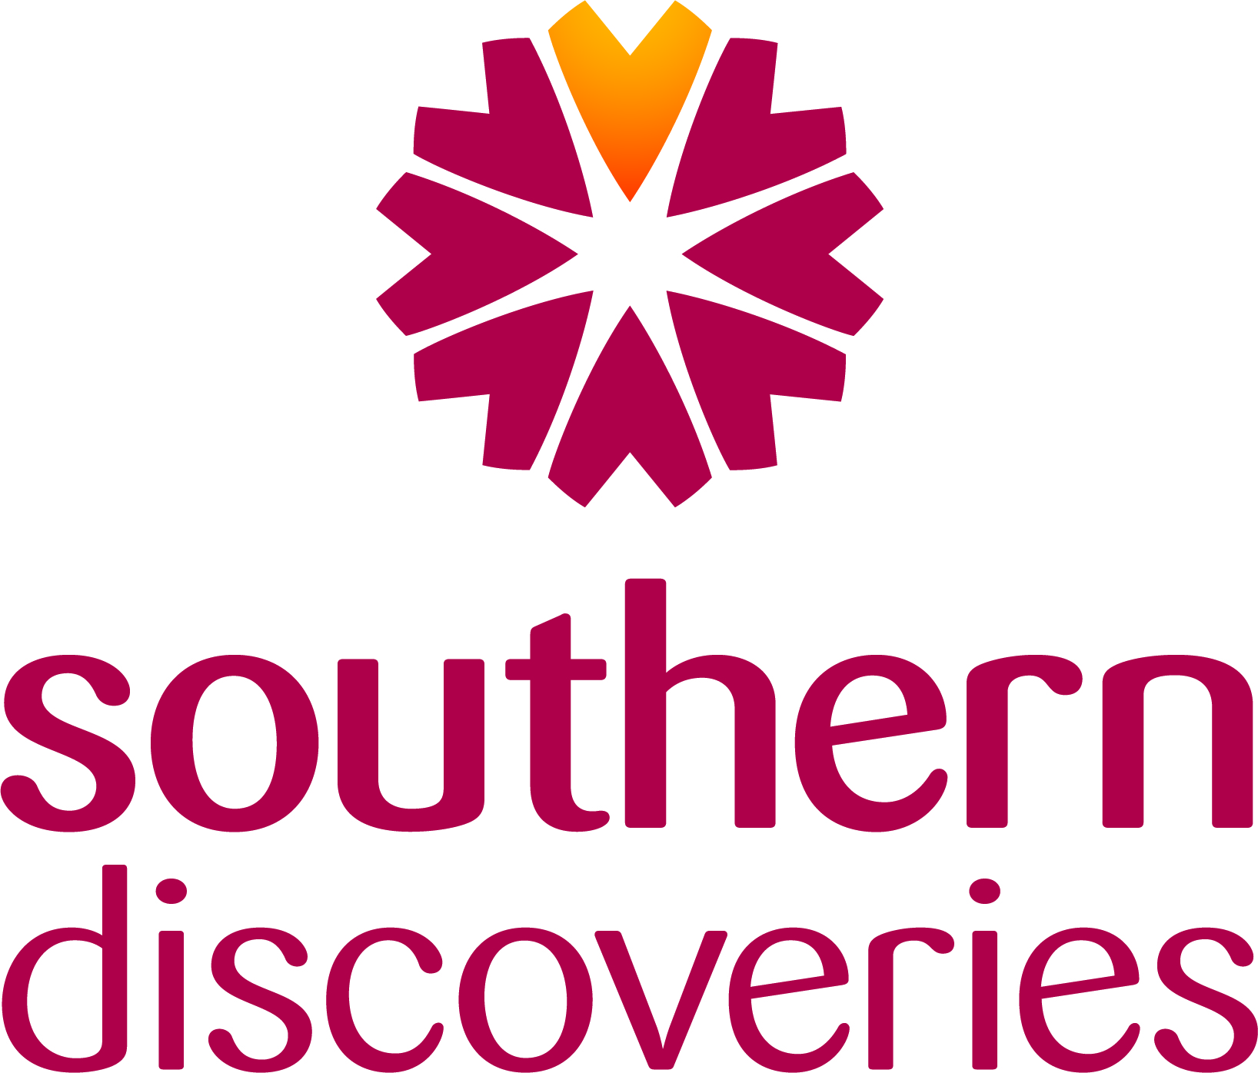

Sales and Marketing Coordinator
POSITION DESCRIPTION

BUSINESS UNIT: SALES AND MARKETING
LOCATION: Queenstown

Position Summary
The Sales & Marketing Coordinator provides essential support across Southern Discoveries’ sales and marketing functions, enabling channel growth, agent engagement, and the smooth delivery of campaigns and partner activity. This is a role suited to a graduate or early-career tourism professional looking to develop strong foundational skills in sales, marketing, technology, and tourism distribution.

The role focuses on coordinating local agent engagement, supporting trade and partnership activity, maintaining accurate CRM and content information, assisting with marketing campaigns, and ensuring brand and product information is up to date across all channels. It supports both the International Sales Manager and the Marketing team, ensuring alignment between sales activity, partner requirements, and marketing delivery.

Position Mission
To support the growth of Southern Discoveries’ channels by delivering effective coordination, accurate information, strong agent engagement, and seamless support to the wider Sales and Marketing teams.

The mission of this role is to:

- Supporting channel development through local agent engagement and partnership coordination.
- Maintaining accurate product, pricing, and content information across CRM, channels, and collateral.
- Assisting with marketing campaigns, promotions, and digital content delivery.
- Using technology and reporting tools to support sales activity and track performance.
- Providing high-quality administrative and organisational support to ensure efficient delivery of commercial outcomes.

Reporting Responsibility
This position reports to the General Manager Sales, reporting to the General Manager of Marketing for marketing related tasks.

Health & Safety

Under the Health and Safety at Work Act (HSWA) 2015, all staff must take responsibility for health and safety, and ensure wherever practicable and reasonable that they, or others, are not harmed by something they do, fail to do, or do incorrectly.
Promptly report any accident, incident or near miss that occurs in the workplace using the appropriate procedure.
Maintain a safe working environment by monitoring safety procedures and equipment.
Understand how to use equipment effectively in accordance with manufacturers’ instructions.
Be knowledgeable of procedures in the event of emergencies such as fire, earthquake, in line with company policy and legislation.
Adhere to all operating procedures including identifying and acting upon any new hazards or risks.
Suggest improvements and participate in Health & Safety matters.
Attend and participate in Health & Safety meetings.
Where appropriate assist passengers in case of emergency, and be observant of guests to ensure general safety.

Sales Support and Local Agent Engagement
- Manage and grow sales performance across assigned local agents, retail partners, and regional distributors, supporting broader channel objectives set by the Sales team.
- Develop and maintain strong, long-term relationships with local agents and frontline partners, ensuring Southern Discoveries is their preferred operator.
- Undertake structured account management for assigned agents, including regular engagement, scheduled visits, virtual check-ins, and basic performance reviews informed by available data.
- Deliver agent training and product updates through in-person sessions, webinars, digital content, or coordinated materials from the Sales and Marketing teams.
- Act as the primary point of contact for assigned local agents, ensuring seamless communication, timely updates, and alignment between partner needs and internal teams.
- Provide feedback from agents to the Sales and Marketing teams regarding product performance, customer trends, competitive activity, and promotional opportunities.
- Support the International Sales Manager with coordinating activity across key local partners that feed into wider trade and wholesale channels.
- Support the International Sales Manager and wider Sales team by coordinating activity across channels including trade, wholesale, and retail partners.
- Maintain regular engagement with local agents, retail outlets, and frontline partners to ensure product knowledge, availability, and promotional alignment.
- Provide up-to-date product information, pricing updates, and training resources to local partners and frontline teams.
- Support familiarisations (FAMs), agent visits, and trade hosting, ensuring high-quality delivery and follow-up.
- Assist with preparation of partner presentations, collateral packs, reports, and digital training tools.
- Support GM Sales as required.
Marketing and Campaign Coordination
- Support the Marketing team in coordinating campaigns, promotions, and partner marketing activity across all channels.
- Ensure all product, pricing, schedule, and content updates are accurately reflected across digital platforms, trade channels, and partner-facing materials.
- Assist with planning and delivering seasonal campaigns by preparing assets, gathering content, organising approvals, and tracking basic performance metrics.
- Coordinate updates to the website, social content, and digital listings in collaboration with the Marketing team.
- Maintain and distribute marketing collateral, ensuring internal teams and partners have up-to-date resources.
- Support the execution of co-operative marketing activity with trade partners, including content preparation, approvals, distribution, and reporting.
- Assist with the setup and administration of marketing tools and systems (e.g., CRM, marketing automation platforms, analytics dashboards).
- Provide campaign and content support to the International Sales Manager, ensuring sales and marketing activity remains aligned.

Technology, Reporting and CROM Management
- Maintain accurate data within the company CRM and other commercial systems to support reporting and decision-making.
- Assist with reporting requirements including monthly sales dashboards, campaign insights, and partner activity summaries.
- Use digital tools such as CRM, marketing automation systems, and analytics platforms to support commercial activity.
- Ensure partner listings, digital profiles, and product information remain up-to-date across external platforms.
General
- Provide support to both Sales and Marketing teams as required.
- Assist with events, trade shows, seasonal onboarding and internal communications.
- Support internal teams with product knowledge updates, collateral requests and day-to-day information needs.
- Provide administration and office support cover for the office in the absence of the Office Manager.
Personal Attributes and Skills
- Enthusiastic, proactive, and eager to grow a career in tourism, sales, or marketing.
- Strong communicator with the ability to build rapport and trust with partners and colleagues.
- Organised and detail-focused, able to manage multiple tasks and maintain accuracy.
- Comfortable using CRM systems, digital tools, and reporting platforms, or willing to learn quickly.
- Creative thinker with an interest in marketing, storytelling, and customer experience.
- Collaborative team member who enjoys supporting others and working in a fast-paced environment.
- Professional, reliable, and committed to delivering high-quality work.
Qualifications and Experience
- Relevant tertiary qualification in tourism, marketing, communications, or business; or equivalent industry experience.
- Experience working in a tourism, hospitality, or customer service environment preferred.
- Strong digital literacy, with familiarity in CRM, digital platforms, or marketing tools an advantage.
- Excellent written and verbal communication skills.
- Current driver’s licence and legal right to work in New Zealand.

